Protection Concept Cyclocross Meilen «Radquer am Zürichsee» vom 2. Jan. 2022
This protection concept refers to the current situation of the pandemic
Ordinance on Measures in the Special Situation to Combat the Covid 19 Epidemic
The Swiss Federal Council of 23 June 2021 (as at 20 December 2021)
Based on Article 6 paragraph 2 letters a and b of the Epidemic Act of 28 September 2012 (EpA)
Implementation of measures
A certification obligation (3G) applies on the entire racing grounds and in accordance with Article 14. In all indoor areas the certificate obligation (2G) applies. The certificate obligation applies to all persons from 16 years of age. The start number issue is located in the semi-open indoor area, which is marked by an entrance and exit area. In the zone of the start number distribution 3G is valid. It is particularly important to ensure that the distance rules of 1.5 m are strictly observed.
Riders have access to the number collection area. Athletes under 12 years of age will be admitted to the race number collection if accompanied by a parent. Disinfection racks will be available in front of the number collection area.
The race area is located in the open countryside, sports facility and agricultural land.
There will be an outdoor restaurant with limited seating in the open air.
Despite the compulsory certificate (2G), masks are compulsory in all indoor areas.
Access control (checking of Covid certificates) of visitors and riders will take place in the area of the designated entrance controls and on the race site. Visitors without a valid Covid certificate will not be allowed access. During access control, all persons over 16 years of age, whether visitors or participants, will be checked for a valid Covid certificate. At the same time, every person over the age of 16 will be checked against an official ID.
The "COVID Certificate Check" app provided by the Confederation is used to check Covid certificates.
Only CH and EU Covid certificates with QR code will be accepted, alternative proofs will not be accepted.
All persons who have successfully passed the access control will be identified by means of a coloured wristband.
General compliance with current hygiene measures applies to the entire event area. The rules such as hand hygiene, distance rules and the wearing of protective masks indoors will be pointed out with appropriate posters.
Hand disinfection dispensers are available at publicly accessible facilities (e.g. toilets).Maximale Anzahl Personen in Räumen (z.B. Toiletten), müssen strikte eingehalten werden. Entsprechende Deklarationen sind angebracht.
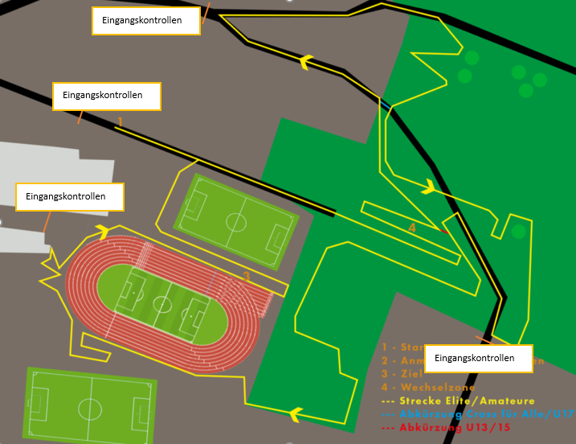

Covid Verantwortliche
Reto Furrer Florian Menzinger
079 706 25 06 079 567 84 05
furrerreto@hotmail.com florianmenzinger79@gmail.com

